**Abstract**

A wholesale management system is a software application designed to help wholesalers manage their operations efficiently and effectively. The system provides a range of features, including inventory management, order processing, sales tracking, customer management, analytics and reporting, integration with other systems, barcode scanning, purchase order management, pricing and discount management, and mobile access.

By using a wholesale management system, businesses can automate and streamline their operations, reduce errors, improve efficiency, and increase profitability. The system allows wholesalers to track inventory levels in real time, manage purchase orders, process orders efficiently, and manage customer relationships. Additionally, the system provides analytics and reporting features to help businesses make informed decisions and optimize their operations.

When choosing a wholesale management system, it is important to select a system that meets the specific needs of your business. Businesses should consider factors such as the size of their inventory, the number of customers they have, and the channels through which they sell their products. Additionally, businesses should select a system that is scalable and can grow with their business. Overall, a wholesale management system is a powerful tool that can help wholesalers manage their operations effectively and efficiently.

**KEYWORDS:**

* Wholesale management system
* Inventory management
* Order processing
* Analytics and reporting
* Scalability

**1. INTRODUCTION**



Wholesale management system is the process of buying the stocks from the buyers and then selling it to the customers. It acts as a middle person between the buyers and the sellers. The manager has to buy the stock from the buyers. Managing the details that is regarding the whole sale is not possible to be kept in track through the pen paper mode. It requires the database system where we can store the information of the people involved in the whole sale system management. It can be stored clearly in the database with more precision and can avoid the redundant data. In most developing countries such as ours, wholesale businesses are still managed using a pen and paper methodology even with the advent of the age of technology and internet. This can sometimes leads to inefficient handling of day- to-day business matters and can also lead to security threats to the business due to the presence of physical records.

This project aims to develop sales management web application for a wholesale business to improve the efficiency and security of the business. The lightweight nature of the web application makes it ideal for small businesses which cannot afford the expensive alternates present in the market.

The Wholesale Management System (WMS) has an administrator login for the wholesaler with built-in features to keep a check on the sales and the inventory so as to efficiently run the sales division. The customers and suppliers of the wholesale business can also be registered so as to ensure the smooth functioning of sales. There is also a customer login option which helps the customer in monitoring his purchases from the wholesaler. By having the above features, the WMS greatly simplifies the daily functioning of the business.

Since, many developed countries already use such software to speed up daily business activities; a lot of information is available in the public domain regarding the desirable structure of such software. We have used this information to design and model our project.

The wholesale management database system can contain the details of the stock that is brought from the buyers like id, name, quantity etc. The information of the buyers like buyer id, name, stock, address, contact number etc can be collected and stored in the database. The manager is responsible for collecting all these information regarding the buyers. In case of any complaints about the stock that is purchased from the particular buyer then you will be able to contact him at ease. There will be customers who will be having the pending bills that need to be cleared and can be contacted about the pending payment. The profit per month is calculated after deducting all the expenditures spent. So the profit of every month can also be stored. If you want to know the profit gained five years back, you can get it done through this database. Quantity cannot be sold to the customer if the amount is not present in the stock. The date of delivery can be maintained up to which the stock can be provided. The objective of this Website is to provide Small Whole Sale businesses to client through online mode. This will help the user to have different type of Whole Sale management services etc.

A wholesale management system is a software solution designed to help wholesalers manage their inventory, sales, and customer relationships. A robust wholesale management system can help wholesalers streamline their operations, improve their efficiency, and increase their profitability.

Here are some key features of a wholesale management system**:**

1.Inventory management: The system should allow wholesalers to track their inventory levels in real-time and automatically reorder products when necessary.

2.Sales management: The system should enable wholesalers to process orders, generate invoices, and track payments.

3.Customer relationship management: The system should enable wholesalers to manage their customer data, such as contact information and order history.

4.Reporting and analytics: The system should provide wholesalers with insights into their sales performance, inventory levels, and other key metrics.

5.Analytics and Reporting: A wholesale management system should provide analytics and reports on key metrics such as inventory turnover, sales performance, and profitability.

6.Integration with other systems: The system should be able to integrate with other software solutions, such as accounting software and ecommerce platforms.

When selecting a wholesale management system, it's important to choose a solution that meets the unique needs of your business. Some key factors to consider include the size of your business, the types of products you sell, and your current technology infrastructure. Overall, a wholesale management system can help businesses improve their efficiency, increase sales, make better decisions, enhance customer service, and integrate with other systems. By using a wholesale management system, businesses can improve their competitiveness and position themselves for long-term success. This project aims to develop sales management web application for a wholesale business to improve the efficiency and security of the business.

Wholesaling is a fun, challenging, and financially rewarding eCommerce business model. Learning [how to run a wholesale business](https://www.bluecart.com/blog/how-to-run-a-wholesale-business) and [how to run a wholesale distribution business](https://www.bluecart.com/blog/how-to-run-a-wholesale-distribution-business) is essential. On the surface, it may look like you can buy raw goods, repackage them, and sell them. However, there’s a lot more to wholesale business operations than this.

Getting familiar with wholesale includes wholesale licensing, how to buy and sell goods, where to find suppliers, marketing and sales strategy, and pricing. Let’s walk through the process of getting a wholesale business set up step-by-step.

There are at least three definitions of the term wholesale. One, the word wholesale itself can refer to a complete or partial product that was acquired from a manufacturer.

Two, wholesale can refer to a business that buys wholesale goods and resells them to another business. Three, wholesale can mean a business that sells wholesale products to individual consumers at a profit.

How Does Wholesale Work?

It’s easy to understand how wholesale works once you become familiar with each of the relationships involved in the process. Here is what it usually looks like:

1. The creator of raw materials sells their goods to a manufacturer.
2. A manufacturer sells their products or parts to a wholesaler.
3. The wholesale broker or merchant sells their goods to another eCommerce or [wholesale marketplace,](https://www.bluecart.com/marketplace) retailer, or consumer.
4. Wholesale brokers ship products to retailers who add their own profit margin to the products. Wholesale merchants sell their goods to consumers, and their profit margin is typically adjusted as a result.

Wholesale distribution refers to the services wholesalers provide between private sellers or manufacturers and retailers. This is a crucial stage in demand management, as each party benefits from the following steps. First, the wholesaler acquires goods from a private seller. This seller may be a large manufacturing company or a handmade product creator. Second, the wholesaler identifies relevant retail opportunities through which to sell the manufacturer’s goods. Small manufacturers may not have the resources to sell their products directly to retail. Third, the wholesaler sells the goods to retail outlets in smaller quantities. They are the link between the original seller of goods and the company providing goods to consumers.

Getting acquainted with the wholesale industry positions you for long-term success. This knowledge allows you to carve out a niche, develop key relationships, and drive efficient business results.

When you’re ready to start your business there are crucial decisions to make. Let’s examine the basics of starting a wholesale business. Wholesaling is competitive, but there has rarely been a better time to start a wholesale business than today. The range of digital tools available today has made sourcing, producing, marketing, and selling goods a faster process.

Knowing how to start wholesaling requires industry knowledge, a few financial resources, and an excellent B2B marketing plan. Here is how to start a wholesale business:

1. Decide on the type of products you want to sell. Wholesaling includes everything from electronics and mechanical parts to jewelry materials and food.
2. Determine the type of wholesaling you want to do. If you’re a broker, you’ll be selling to other producers. If you’re a merchant, you’ll be selling wholesale goods directly to consumers.
3. Narrow down your target market. Uncover a pain point amid a wider market and sell directly to those buyers.
4. Identify relevant manufacturers or suppliers. Make sure that you’re both getting a good deal and working with a certified vendor.
5. Complete relevant paperwork. This is the least fun part of getting a business started, but is necessary and legally protects your work.

**2. LITERATURE SURVEY**

Wholesale management is an important aspect of supply chain management and involves the planning, organizing, and controlling of the flow of goods from suppliers to retailers. There is a vast amount of literature on wholesale management, which covers various topics such as inventory management, pricing, supply chain coordination, and logistics. Here is a brief survey of the literature on wholesale management:

Inventory Management: The management of inventory is a critical aspect of wholesale management. The literature on inventory management covers topics such as safety stock, order quantity, reorder point, and inventory turnover. Some of the popular models used in inventory management include the Economic Order Quantity (EOQ) model, the Reorder Point (ROP) model, and the Just-in-Time (JIT) model.

Pricing: Wholesale pricing is a key driver of profitability in the wholesale industry. The literature on pricing covers topics such as pricing strategies, price discrimination, and price competition. The most common pricing strategies used in wholesale management are cost-plus pricing, value-based pricing, and competitive pricing.

Supply Chain Coordination: Effective coordination among supply chain partners is essential for the success of wholesale management. The literature on supply chain coordination covers topics such as information sharing, collaboration, and coordination mechanisms. Some of the commonly used coordination mechanisms in wholesale management include vendor-managed inventory (VMI), consignment inventory, and collaborative planning, forecasting, and replenishment (CPFR).

Logistics: Efficient logistics management is critical for the smooth functioning of wholesale operations. The literature on logistics covers topics such as transportation, warehousing, and order fulfillment. Some of the popular logistics strategies used in wholesale management include cross-docking, direct store delivery (DSD), and drop shipping.

In summary, the literature on wholesale management is vast and covers various topics related to the planning, organizing, and controlling of the flow of goods from suppliers to retailers. Understanding the various aspects of wholesale management is crucial for businesses looking to optimize their supply chain operations and improve profitability.

Here are some key findings from a literature survey on wholesale management systems:

According to a research paper by M. K. Gupta and K. N. Agrawal, wholesale management systems can help businesses improve their efficiency, reduce costs, and increase customer satisfaction. The paper also notes that wholesalers can use these systems to optimize their supply chain and reduce inventory carrying costs.

A study by the Aberdeen Group found that businesses that use wholesale management systems can reduce their order processing times by up to 50%. The study also notes that these systems can help businesses reduce errors, improve accuracy, and increase order volumes.

According to a report by Frost & Sullivan, the global wholesale management system market is expected to grow at a compound annual growth rate of 12.5% between 2020 and 2027. The report notes that the increasing adoption of cloud based solutions, the growth of ecommerce, and the need for better supply chain management are driving the growth of this market.

A research paper by J. J. Zhang and H. Zhang highlights the importance of real time inventory management in wholesale management systems. The paper notes that real time inventory management can help businesses reduce stockouts, prevent overstocking, and improve customer satisfaction.

A study by the University of Arkansas found that businesses that use wholesale management systems can reduce their lead times by up to 42%.

The study also notes that these systems can help businesses improve their order accuracy and reduce their overall inventory levels.

According to a report by Gartner, businesses that use wholesale management systems can improve their overall supply chain visibility, reduce their inventory carrying costs, and increase their order accuracy. The report also notes that businesses that use these systems can improve their customer service levels and reduce their order cycle times.

Overall, the literature survey suggests that wholesale management systems can provide businesses with a range of benefits, including improved efficiency, reduced costs, increased customer satisfaction, and better supply chain management. The survey also highlights the importance of real-time inventory management and the need for businesses to choose a system that meets their specific needs and requirements.

A wholesale management system is a software application that helps businesses manage their wholesale operations, including inventory management, sales, purchasing, order processing, and customer management. There is a significant amount of literature on wholesale management systems, which covers various aspects of the technology, including implementation, benefits, and challenges.

The literature on wholesale management systems covers various aspects of the technology, including implementation, benefits, challenges, and features. Understanding the benefits and challenges of wholesale management systems is critical for businesses looking to improve their wholesale operations and gain a competitive advantage in the marketplace. Wholesale system is the process of buying the stocks from the buyers and then selling it to the customers. It acts as a middle person between the buyers and the sellers. Management system ensures the proper dealing and security of the data of the shop.

**3. PROBLEM DEFINITION**

Wholesalers and retailers are engaged in selling products that have been bought from the suppliers. They bring the products manufactured in a particular region or imported from different locales and nations to the open market, easily accessible for consumers to buy. As you can guess from the nature of the business, there are a lot of challenges or problems that wholesalers or retailers may encounter in the process. In this article, we will tell you the 5 biggest challenges in the Wholesale Business and measures to solve them.

**The Five biggest challenges in the Wholesale Business**

1.Inventory Shortage & Overstocking -The two extreme sides of the supply chain cycle, shortage, and overabundance of goods are a horror feared and faced by all the businesses today at some point or the other. While the shortage of inventory keeps you from fulfilling customer demand, inventory sitting in large quantities in the warehouse also results in loss of all kinds. In case of overstocking, you have to incur maintenance costs such as security costs, costs of the inventory manager, costs of the space. This will be a recurring cost if the inventory sits in the warehouse for long periods. In case there is a demand for your product but you don’t have any to offer to your customers, you risk your customer base.

### Solutions to Overstocking and Understocking of Inventory- The only way to avoid overstocking or shortage of inventory is by being at the top of your inventory management game. It helps you to maintain an optimal amount of inventory.

### A. Track your Inventory Turnover Ratio (ITR) -The [Inventory Turnover Ratio gi](https://www.deskera.com/blog/inventory-turnover-ratio/)ves you the number of times inventory is sold or consumed in a given period. By keeping a close eye on your ITR, you will know exactly what to restock, when to restock and the goods that you no longer need to fill your warehouse with.

### B. Identify Fast, Slow & Obsolete Items -In an inventory-based business, it is easy for you to understand the nature of your products by tracking their movement. You must identify the obsolete goods, fast and slow-moving goods of your company, and track your inventory costs accordingly. Once you have identified that ‘X’ number of goods are fast-moving goods because of their high demand, you can always keep stock to fulfill customer demand. In the case of slow-moving goods, you can either have discount sales for that product, minimize the production, or you can opt for [JIT. O](https://www.deskera.com/blog/jit-just-in-time-inventory/)n the other hand, there is no backup for obsolete goods or dead goods. Once you have identified the set of obsolete goods you must ensure that you don’t deal with those products at all or in large quantities.

### C. Optimize Pick, Pack, Ship Process -The [Pick, pack & ship, i](https://www.deskera.com/blog/pick-pack-ship/)s a basic process of delivering goods successfully. Although it is a common delivery process, doing it right makes all the difference. You must take control of the pick, pack, and ship process by closely monitoring it. Moreover, since the process can be done both manually and with automation, following the process can be very easy. For example- if you have to deliver a product not readily available to you for delivery, you can immediately leave a mail for your warehouse manager and let him know which product and quantity you need. Now, to avoid the last-minute runs in the warehouse to find the required product, you can share the exact location of the product lying in the warehouse with your warehouse manager. The product can be further packed and shipped to you. Optimizing your Pick, Pack, Ship streamlines your delivery process.

### 

### D. Know Your Reorder Levels & Minimum Order Quantities- A reorder level is the minimum inventory level for a particular product that triggers the reordering of more inventory. When you are aware of your reorder levels, you don’t fall behind on your next set of inventories. You always have products in stock before you get the new set to fulfill customer demands. On the other hand, a minimum order quantity (MOQ) is the lowest set amount of stock that a supplier is willing to sell. Products that cost more to manufacture will usually have a lower MOQ than the products that are easy and cheap to produce. MOQs allow suppliers to increase their profits while getting rid of more inventory more quickly. A good way to do business with MOQ products is, if you have product ‘X’ that you are selling to retail customers who are buying in less quantity, you sell a pack of ’X’ for Rs.15. At the same time, if you want to sell it wholesale you must reduce the amount to Rs.10 with an MOQ of 150 packs. This helps you to attract buyers and get rid of the inventory.

2.Poor Visibility into Product Profitability-Business owners often lack the knowledge or latest updates on how profitable their products are. It is nothing but a result of a weak inventory tracking system. While companies can make an easy comparison between the cost of goods sold at the beginning of a year and the end of the year, real-time tracking is not a common practice. Real-time poor visibility of inventory movement, inventory costs, and inventory costs of goods sold, may leave a blind spot in terms of product profitability. There are factors like hidden inventory costs, inventory storage, the manpower that you assign to move the inventory around, delivering it, and transportation costs. All of these factors should be taken into consideration when you are looking at the profitability of your product. These factors or these costs are often not visible in the inventory reports. So, what can you do to improve your visibility into product profitability. Here are a few solutions to overcome this problem of poor visibility into product

Solutions to Poor Visibility of Profit Margins

A. Track cost of Goods Sold Accurately- To improve your visibility into product profitability, you must begin by tracking the costs of the goods sold. All you require to track the [cost of goods sold (CO](https://www.deskera.com/blog/cost-of-goods-sold/)GS) is a good accounting system. By a good accounting system, we mean a real-time goods tracking system. Within a few taps in the system, you will have your cost of all the goods readily available to you. Instead of waiting until the end of the week to receive a report on the COGS, you can access it whenever you want during the week. It is important to remember that the COGS is not just a purchase cost but includes the other additional costs that you have incurred. You must take COGS and additional costs into consideration before deciding which supplier would be the best.

### B. Track Profitability by Product Categories & Brands- As a wholesaler, you have a variety of products to satisfy your customer demands. Despite having an ample amount of products to offer you always want to stock on more and substitute goods especially to provide to your customer. However, if you are not tracking the profitability of the goods by a particular brand and category of the product, then you might end up stacking unprofitable goods. By tracking the profitability of the goods category-wise and brands, you will be able to identify what is causing your ITR to go down.

### 

### C. Track Hidden Inventory Costs -Your inventory is a useful asset, and if you manage it correctly, you will see your business reach new heights of success. However, it is important to notice the [hidden inventory costs th](https://www.deskera.com/blog/inventory-cost)at your inventory comes with. The hidden costs can be roadblocks in your journey. Your hidden inventory costs vary from labor costs, transportation fees, storage fees, delivery fees, and so on. By tracking these costs you can easily monitor your product profitability. But if you miss out on these costs you will never know the accurate product profitability rate. Using bette[r inventory control me](https://www.deskera.com/blog/inventory-control/)thods will help you keep track and keep the costs down.

## 3. Mismatch in Customer & Supplier Demands- A mismatch in customer and supplier demands or unevenness of the supply of goods with their need in the market has been a constant issue for many business owners. In the supply chain process first, you receive an order from the customer, place the order to your supplier, then the supplier confirms the date of delivery to you, and you can deliver the products to your customer further on. This may seem like a straightforward process, but it has a lot of complexity, which can lead to a mismatch in the process. For example, if there is a customer who requires a set of products immediately and you don’t happen to have it, you will ask your supplier for the goods. However, the supplier requires a lead time to deliver it. This mismatch in customer and supplier demands not only causes a delay in customer service but eventually leads to overstocking or a shortage of goods.

Solutions to Mismatch in Customer and Supplier Demands

A. Backorder- A backorder is an order for a product that cannot be filled at the current time due to a lack of available supply. For example, as soon as you reach zero stock and a customer requires a specific product and you don’t have enough inventory to cater to their demand, you can backorder the goods immediately.

B. Track Future Inventory In & Inventory Out- Imagine you have a lot of deliveries to make to your customers and have a large number of orders coming in from your suppliers too. And unfortunately, you lose track of these inventories coming in and going out. As you may have guessed, this causes a mismatch in customer and supplier demands in the end. To avoid this it’s necessary to track your inventory in and inventory out. A good way to track your inventory in and inventory out is by use of the Inventory Management System. It tells you how many orders you are still supposed to receive from your suppliers and the number of orders you have to fulfill. The inventory in and out report will prepare you for the future. It will give you an idea of the mismatch in supply and demand you might face over the next quarter, months, or weeks.

C. Rank Suppliers on Lead Times, Quality & Cost - In the market, like wholesalers have competition amongst themselves, the suppliers have competition too. This competition between the suppliers can be healthy for you and a little confusing as well. It is healthy for you because every supplier would want to propose their best deal to you and the best product. While this gives you innumerable options to make your pick, it can be confusing to decide which one to for. If you end up making the wrong decision a possibility of mismatch in customers and supplier demands will be higher. Eventually costing you a lot and leading to losses. The majority of the wholesalers just look at the cost suppliers are offering to them and make their decisions. However, this can be a step in the very wrong direction.

### D. Know Who Your Preferred Vendors Are - Once you have ranked your suppliers, the next step is to identify your preferred vendors for ordering items. While you still want to keep a list of vendors handy and order from a pool (something about putting all your eggs in one basket), it is important to keep this handy because you can configure process rules based on reorder levels, minimum order quantities and map them to your preferred supplier list. With a small amount of automation, you can raise automatic POs to your preferred vendors with the minimum order quantity with auto-approvals to make this process faster and get goods shipped quicker to match any fluctuations in demands.

4. Profit Margins & Cash Flow- Improving profit margins and cash flow is at the forefront of any business. The challenges faced by wholesale and retail businesses in improving these numbers are: Inventory storage costs, Pricing wars/ Bidding wars for new orders, Late payment against invoices, Expenses around forex transactions

Solutions to Improving Profit and Cash Flow

A. Explore dropship options for reducing inventory storage costs - One of the main, big costs that wholesale traders deal with is the storage costs. Especially when you have goods lying around for a long time, your storage costs shoot up. But today, what if we tell you that you can do away with it. Drop shipping is a type of retail fulfillment that lets you sell products without managing your inventory. You connect with drop shipping suppliers and source products to deliver to your customers. In this way, you can easily increase your profit margin by saving up on storage costs. Maintain price lists & use volume based pricing Be prepared to enter bidding wars by keeping your price lists handy. Maintain prices lists by volume, by region, by types of customers and know how low you can go while turning a profit. You can use volume pricing when you want to incentivize the sale of higher quantities of individual products.

### B. Make it easy to get paid with online options -Online payment options have taken the market by storm. Everyone is going cashless today. Especially in the wholesale sector or retail trading, you are dealing with bulk and bulk of goods and multiple suppliers. To always rely on cash can be a very slow movement. Online payment options make the process quick and more authenticated. Your money reaches directly in your bank. If you have to make any payments you don’t have to wait for an associate to collect them from you. You can use multiple payment gateways like Stripe, Paypal, Veem and many others to give more payment options and reduce the time to get paid. This can improve your time to get paid by as much as 5 times.

### 

### C. Control forex gain/loss and transaction fees -A foreign exchange gain/loss may occur when a company purchases and/or sells goods and services in a foreign currency. When that currency value fluctuates as compared to their currency at home, it will create differences in the value in the monetary assets and liabilities. Track your forex gain/loss and map it to vendors/customers. If you are encountering significant losses while transacting with suppliers or customers from a particular country, then you can explore entering into fixed exchange rate contracts instead of letting the market decide your fate. Another factor is the admin or transaction fees for forex transfers. You have to pay transaction fees if you are using a service to pay someone overseas. These transaction fees are as high as it gets and a waste of your money. To minimize the transaction fees, you can opt for online money transfer options like [TransferWise th](https://www.deskera.com/blog/deskera-wise-transferwise/)at charge you minimum transaction fees on each payment made

### 

## 5. Slow Growth - Every industry, every business today wants faster growth. However, wholesale and retail traders see an annual growth rate of an average of 5%. If you compare 5% with other sectors, while the percentage is not bad, there is a big room for improvement. One of the major challenges or driving factors of this slow growth in the wholesale and retail trading business is the expansion of business and relationships.

Solutions to Achieve Faster Growth

A. Expand internationally- Start by reaching out to more customers. You cannot keep your contacts limited to a few customers, and expand your business. If you are recycling the same contacts that were collated many years back then no wonder you are on a slow track of growth. You must build contacts locally as well as internationally. If you want growth in your business you must build new, strong contacts.

### B. Get a website, online store, and a simple blog- In the world of social identity and brand identity, you cannot keep your brand identity limited to your office or products. You must explore new platforms where you can connect with other people. Create spaces within your website for customers to openly discuss your products. This not only helps you promote yourself but builds closer connections with your customers.

The 2020 pandemic taught us the value of online visibility, when you don’t have a physical space, you can make all the difference virtually. Especially blogs, they can do wonders. They help you rule Google and get customer engagement instantly.

### C. Run email campaigns- One of the great options to market your products, your brand, is via [email marketing campaigns.](https://www.deskera.com/blog/b2b-email-marketing-campaigns) We have a curated the best email campaign articles for your benefit below. Please have a look. A research problem helps you identify the approach you must take for the research activity. It helps in the identification of each step you must take to do your research – the sampling strategy, the research design, the research analysis, and the research instruments to be used.

Characteristics of a research problem-Make sure to fulfill these essential characteristics to have an effective research problem. Due to the variety of research, we conduct, it is not possible to inculcate all these characteristics. However, ensure to consider and cover most of these characteristics to enable people to look at, examine, and understand the marketing research problem.

1.Covers the essential needs or issues -The researcher must have a specific problem statement in the research. Unless you don’t address the crucial issues, the research project will not carry much weight. The complex research project may end up wasting time and money if these issues are not of high importance. Ensure you do not miss out on the more critical needs and concerns to get your marketing strategies right.

2.The problem is stated logically and clearly -If you can’t state the problem logically or clearly in the research project, the problem likely is a weak one or probably a non-problem. To test this, consolidate the specific problem into a paragraph and ensure it makes sense and covers all the crucial points. Share the problem with others, and if this is not understood by even s few, consider a more logical approach to specify the issue or problem. The research project is based on actual facts and evidence (non-hypothetical). There is a difference between beliefs and facts. Keep fiction out of this. Research must be based on actual facts and not beliefs. Hypothetical events will not do the research any good. You can’t consider the research findings true or accurate if you don’t base them on facts and evidence. It must suggest a meaningful and testable hypothesis. The research problem generates and encourages research questions

The research must create multiple questions. These questions should be more specific to the research that highlights different components or aspects of the problem. These questions must assist in addressing the issue better, providing a robust framework for the research. Formulating such questions is a challenge that needs to be addressed correctly.

**4. SYSTEM REQUIREMENT SPECIFICATION**

**4.1 Functional Requirements: -**

A functional requirements specification (FRS) is a detailed document that describes the functionality that a software system must provide. Here are the functional requirements for a blockchain-based crowdfunding website:

* User Management: Users must be able to create an account and provide required details like name, email address, password, and other necessary information. The system should provide a secure login facility that verifies user credentials before granting access to the account. The system should allow users to manage their profiles, update their information, and view their funding history.
* Project Management: The system should allow project creators to create new projects, define the funding goal, upload multimedia content like images and videos, and provide a detailed description of the project. The system should allow project creators to set deadlines for funding and the project's completion. The system should allow the administrator to review and approve the project before publishing it on the website.
* Fund Collection and Distribution: The system should allow funders to view a list of available projects and choose to fund any project they prefer. The system should allow funders to choose the cryptocurrency they wish to use to fund the project. The system should hold the funds in an escrow account until the project's funding goal is met.
* The system should release the funds to the project creator once the funding goal is met or return the funds to the funders if the goal is not met. The system should allow project creators to withdraw the funds from the escrow account once the project is completed.
* Project Updates: The system should allow project creators to provide regular updates on the project's progress. The system should notify funders of project updates via email or other means.
* User Feedback: The system should allow funders to provide feedback on the project they have funded. The system should display the feedback provided by the funders on the project page.
* Security: The system should use blockchain technology to ensure secure and transparent transactions. The system should store user data and project information securely and protect them from unauthorized access. The system should follow industry-standard security practices and guidelines to prevent attacks like DDoS and SQL Injection.

Analytics: The system should provide users with relevant analytics, such as the number of projects funded, the amount of funds raised, and other metrics to help them make informed decisions. These are the functional requirements for a blockchain-based crowdfunding website. Additional features may be added depending on the specific needs of the project.

**4.2 Non-Functional Requirements: -**

Non-functional requirements describe the qualities that the system must possess, such as performance, reliability, usability, scalability, and security. Here are some examples of non-functional requirements for a blockchain-based crowdfunding website:

* Performance: The website should be able to handle a large number of users and transactions simultaneously without any noticeable delay or downtime.
* Reliability: The website should be highly available and reliable, with a system uptime of at least 99.9%.
* Usability: The website should be user-friendly, with a clean and intuitive interface that allows users to easily navigate and interact with the system.
* Scalability: The website should be designed to scale up or down as the number of users and transactions increases or decreases.
* Security: The website should be highly secure, with measures in place to protect user data, prevent unauthorized access, and prevent cyber-attacks such as DDoS attacks.
* Privacy: The website should protect user privacy by implementing appropriate measures to secure user data and prevent data breaches.
* Compliance: The website should comply with relevant laws, regulations, and industry standards, such as GDPR, PCI-DSS, and ISO 27001.
* Availability: The website should be available 24/7 with minimal downtime for maintenance and upgrades.
* Accessibility: The website should be accessible to users with disabilities, such as visual or hearing impairments.
* Maintainability: The website should be easy to maintain, with clear documentation, well-organized code, and a modular architecture.

In conclusion, non-functional requirements are essential to ensure that the blockchain-based crowdfunding website meets the required quality attributes and attributes of the system. By taking these non-functional requirements into consideration, you can create a website that is fast, reliable, secure, and user-friendly.

SOFTWARE REQUIREMENTS:

Operating System – Windows 7/8/10/11 (32-bit or 64-bit).

Front End: HTML5, CSS, BOOTSTRAP

Database- MY SQL

PHP (Hypertext Preprocessor)

Browser Support − IE (Internet Explorer 11+), Firefox, Google chrome,

**TECNOLOGY USED**:

PHP: The PHP Hypertext Preprocessor (PHP) is a programming language that allows web developers to create dynamic content that interacts with databases.

PHP is basically used for developing web based software applications.

MySQL: -MySQL is a fast, easy-to-use RDBMS being used for many small and big businesses. MySQL is developed, marketed and supported by MySQL AB, which is a Swedish company.

PHP

The PHP Hypertext Preprocessor (PHP) is a programming language that allows web developers to create dynamic content that interacts with databases. PHP is basically used for developing web based software applications. This tutorial helps you to build your base with PHP. PHP started out as a small open source project that evolved as more and more people found out how useful it was. Rasmus Leadoff unleashed the first version of PHP way back in 1994. PHP is a MUST for students and working professionals to become a great Software Engineer specially when they are working in Web Development Domain. I will list down some of the key advantages of learning

PHP is a recursive acronym for "PHP: Hypertext Preprocessor". PHP is a serverside scripting language that is embedded in HTML. It is used to manage dynamic content, databases, session tracking, even build entire ecommerce sites. It is integrated with a number of popular databases, including MySQL, PostgreSQL, Oracle, Sybase, Informix, and Microsoft SQL Server.

PHP is pleasingly zippy in its execution, especially when compiled as an Apache module on the Unix side. The MySQL server, once started, executes even very complex queries with huge result sets in record-setting time. • PHP supports a large number of major protocols such as POP3, IMAP, and LDAP. PHP4 added support for Java and distributed object architectures (COM and CORBA), making n-tier development a possibility for the first time. PHP is forgiving: PHP language tries to be as forgiving as possible.

## MY SQL-

MySQL is a popular open-source relational database management system (RDBMS) that is widely used for building web applications and managing data. It is a scalable, high-performance database that can handle large amounts of data and is known for its speed and reliability . MySQL are open-source server-side programming languages used to create dynamic websites. They provide flexibility, as they can be used and manipulated on any operating system. PHP and MySQL work together to provide fast web page response times even with slow internet and data speed. It is fast, scalable, and easy to use database management system in comparison with Microsoft SQL Server and Oracle Database.

**5. SYSTEM DESIGN & MODELLING**

**Data Flow Diagram**- Data-flow diagrams (DFDs) model a perspective of the system that is most readily understood by users – the flow of information through the system and the activities that process this information. Data-flow diagrams provide a graphical representation of the system that aims to be accessible to computer specialist and non-specialist users alike. The models enable software engineers, customers and users to work together effectively during the analysis and specification of requirements. Although this means that our customers are required to understand the modeling techniques and constructs, in data-flow modeling only a limited set of constructs are used, and the rules applied are designed to be simple and easy to follow. These same rules and constructs apply to all data-flow diagrams (i.e., for each of the different software process activities in which DFDs can be used).

## The benefits of data-flow diagram are-

* Data-flow diagrams provide a very important tool for software engineering, for a number of reasons:
* The system scope and boundaries are clearly indicated on the diagrams (more will be described about the boundaries of systems and each DFD later in this chapter).
* The technique of decomposition of high-level data-flow diagrams to a set of more detailed diagrams provides an overall view of the complete system, as well as a more detailed breakdown and description of individual activities, where this is appropriate, for clarification and understanding.
* Levels in Data Flow Diagrams (DFD) -The DFD may be used to perform a system or software at any level of abstraction. Infect, DFDs may be partitioned into levels that represent increasing information flow and functional detail.
* Levels in DFD are numbered 0, 1, 2 or beyond. Here, we will see primarily three levels in the data flow diagram, which are: 0-level DFD, 1-level DFD, and 2level DFD.

## 0-level DFDM

## It is also known as fundamental system model, or context diagram represents the entire software requirement as a single bubble with input and output data denoted by incoming and outgoing arrows. Then the system is decomposed and described as a DFD with multiple bubbles. Parts of the system represented by each of these bubbles are then decomposed and documented as more and more detailed DFDs. This process may be repeated at as many levels as necessary until the program at hand is well understood. It is essential to preserve the number of inputs and outputs between levels, this concept is called levelling by DeMarco.

## 1-level DFD

In 1-level DFD, a context diagram is decomposed into multiple bubbles/processes. In this level, we highlight the main objectives of the system and breakdown the high level process of 0-level DFD into subprocesses.

## 1. DFD Level 0

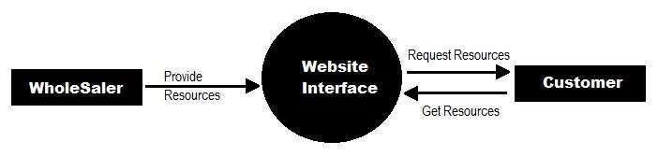

Fig 5.1

ER- DIAGRAM-

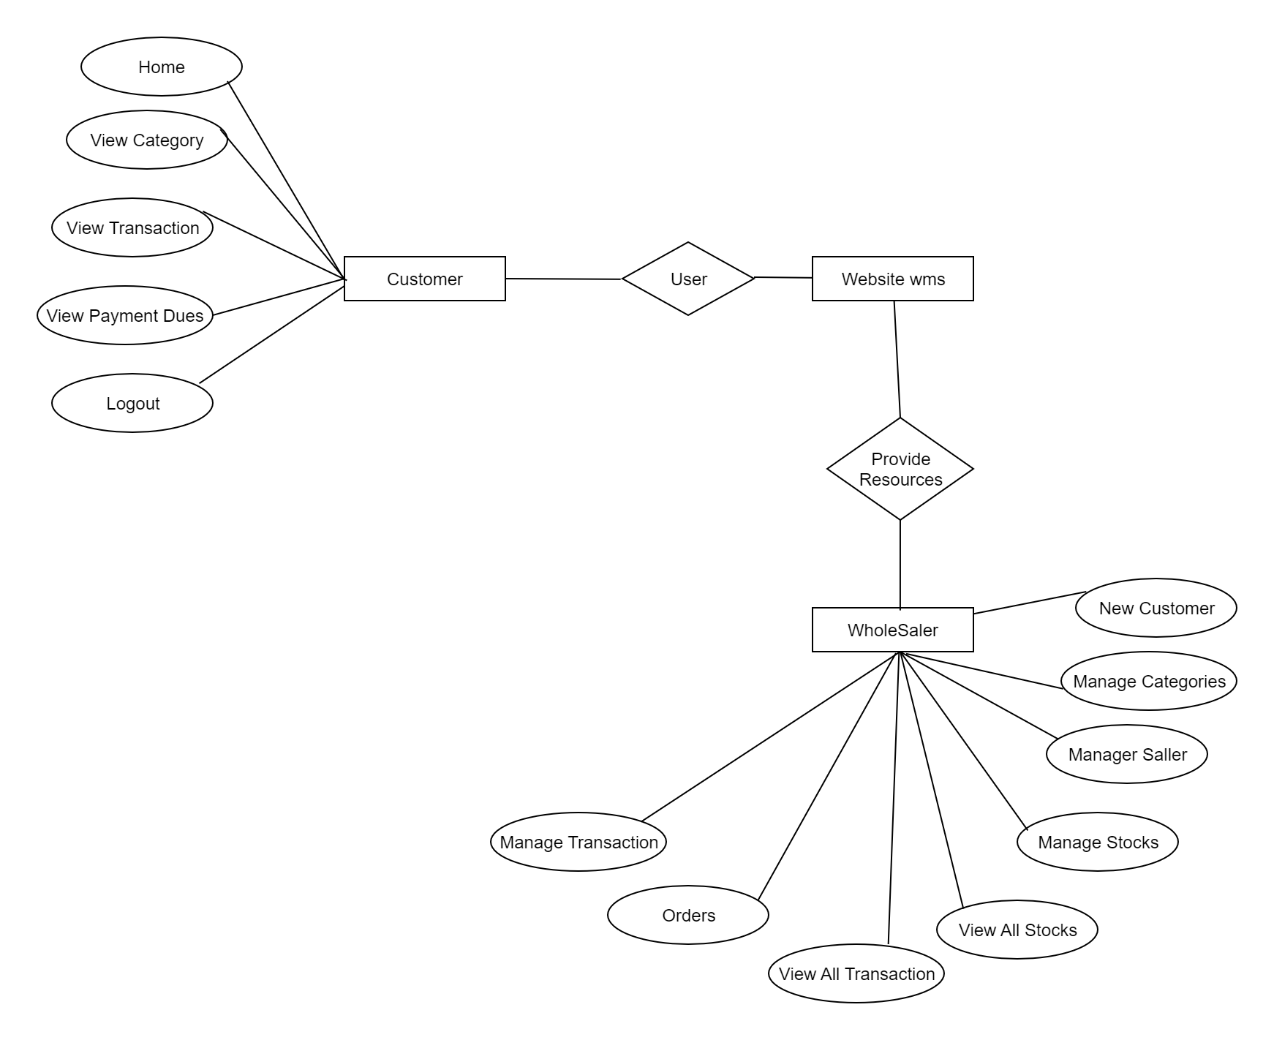

Fig 5.2

### Use Case Diagram - The purpose of use case diagram is to capture the dynamic aspect of a system. However, this definition is too generic to describe the purpose, as other four diagrams (activity, sequence, collaboration, and State chart) also have the same purpose. We will look into some specific purpose, which will distinguish it from other four diagrams. Use case diagrams are used to gather the requirements of a system including internal and external influences. These requirements are mostly design requirements. Hence, when a system is analyzed to gather its functionalities, use cases are prepared and actors are identified. When the initial task is complete, use case diagrams are modeled to present the outside view.

### 

Fig 5.3

The wholesale management database system can contain the details of the stock that is brought from the buyers like id, name, quantity etc. The information of the buyers like buyer id, name, stock, address, contact number etc. can be collected and stored in the database. The manager is responsible for collecting all these information regarding the buyers. In case of any complaints about the stock that is purchased from the particular buyer then you will be able to contact him at ease. There will be customers who will be having the pending bills that need to be cleared and can be contacted about the pending payment. The profit per month is calculated after deducting all the expenditures spent. So the profit of every month can also be stored. If you want to know the profit gained five years back, you can get it done through this database. Quantity cannot be sold to the customer if the amount is not present in the stock. The date of delivery can be maintained up to which the stock can be provided.

## Modules Implemented

1.Stocks management system: The details of the stocks that are present or available can be easily maintained through this application.

2.Customers database management: The details of the customers like name, customer id, address, contact number who buys the stock that is purchased can also be stored.

3.Sales management: The sales that have taken place on the particular day or month can be calculated through this application.

## Applications -

There are two types of accounts: Administrator and Customer.

1.Features for the Administrator: -Add/Update Product Details by accessing them category-wise, Add/Update Supplier Details, Add/Update Customer Details, Stock Maintenance by having a look at the depleted stocks and so forth, View all the transactions taken place in a specified time period, Add a new transaction to the system as it happens offline and store the payment details accordingly, Generate a bill for any past transaction using its unique Transaction ID if required.

2.Features for the customer- View all the transaction done by the logged-in customer for a specified time period, Search through the available products category-wise, Generate bills for any previous transaction done by the customer.

## TABLE OF DATABASE

A database table is a collection of related data organized in a structured format within a database. Tables are used to store and organize data into rows and columns, where each row represents a unique record and each column represents a specific attribute or field of that record.

In a relational database, tables are typically linked together through the use of keys, which enable data to be accessed and combined from multiple tables in a meaningful way. The structure of a database table is defined by its schema, which specifies the column names, data types, constraints, and relationships with other tables in the database. Databases can be categorized into various types, including relational, NoSQL, and graph databases. Relational databases are the most common and use a structured approach to store data in tables with defined relationships between them. NoSQL databases, on the other hand, use a non-relational approach and are more flexible in handling unstructured or semi-structured data. Graph databases are used to manage data that has complex relationships, such as social networks or recommendation systems. In addition to storing data, databases provide mechanisms for adding, updating, and deleting data, as well as querying and analyzing data. Popular database management systems include MySQL, Oracle, PostgreSQL, MongoDB, and Neo4j. Overall, databases play a critical role in managing large amounts of data in an efficient and organized manner, making them an essential tool for businesses and organizations of all sizes. Databases offer several key features that make them valuable tools for managing and organizing data. Here are some of the important features of databases:

Data Organization: Databases provide a structured way to organize and store data. Data is typically stored in tables, with each table consisting of rows (records) and columns (fields) that define the data structure.

Data Integrity: Databases enforce data integrity rules to ensure the accuracy and consistency of data. This includes defining data types, constraints, and relationships between tables. Data integrity rules help maintain the quality and reliability of the stored information.

Data Retrieval: Databases enable efficient retrieval of data based on specific criteria or conditions. Users can query the database using a query language, such as SQL (Structured Query Language), to extract the desired information from the database.

Data Manipulation: Databases support operations for adding, modifying, and deleting data. Users can insert new records, update existing records, or remove unwanted data from the database. These operations are typically performed through data manipulation statements in SQL.

Data Security: Databases offer various security features to protect data from unauthorized access, modification, or disclosure. Access control mechanisms, user authentication, and encryption techniques are used to ensure data security and maintain confidentiality.

Data Consistency and Concurrency: Databases provide mechanisms to handle concurrent access to data by multiple users or processes. They implement techniques like locking and transaction management to maintain data consistency and prevent conflicts when multiple users try to access or modify the same data simultaneously.

Data Scalability: Databases are designed to handle large volumes of data efficiently. They can scale vertically by adding more resources to a single server or scale horizontally by distributing the data across multiple servers to handle increased data loads.

Data Backup and Recovery: Databases offer features for backing up data regularly and recovering it in the event of system failures, data corruption, or disasters. Backup and recovery mechanisms ensure that data can be restored to a consistent and usable state.

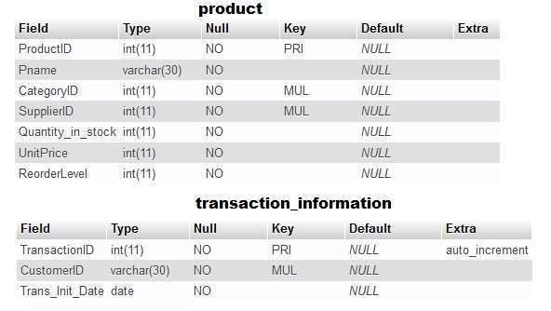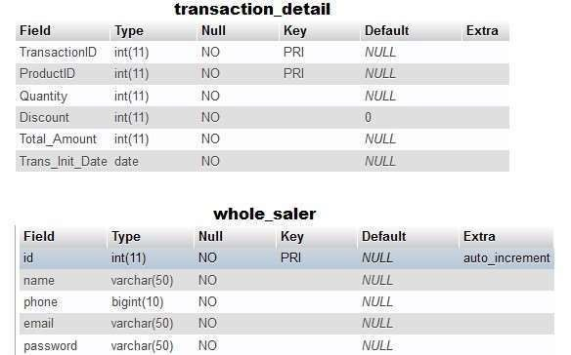

E-R DIAGRAM

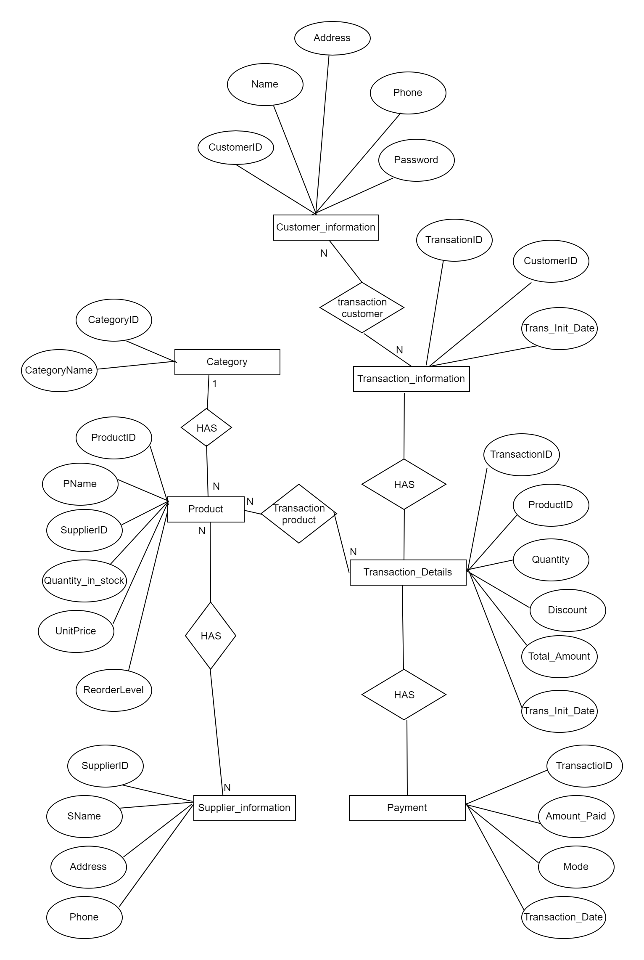

**6. IMPLEMENTATION**

Project implementation is the process of putting a project plan into action to produce the deliverables, otherwise known as the products or services, for clients or stakeholders. It takes place after the planning phase, during which a team determines the key objectives for the project, as well as the timeline and budget. Implementation involves coordinating resources and measuring performance to ensure the project remains within its expected scope and budget. It also involves handling any unforeseen issues in a way that keeps a project running smoothly.

Implementing a wholesale management system involves the following steps:

1.Define requirements: The first step is to define the specific requirements of your wholesale business. This includes identifying what processes need to be managed, such as inventory management, sales order processing, purchase order processing, customer management, and reporting.

2.Research software options: There are many wholesale management software options available in the market, such as QuickBooks, Zoho Inventory, and Trade Gecko. Research these options and determine which one fits your business requirements.

3.Choose a vendor: After selecting a software option, choose a vendor that provides the best fit for your business. Consider factors such as the vendor's reputation, the cost of the software, customer support, and the scalability of the solution.

**4.**Configure the system: Once the software is selected and a vendor is chosen, the system needs to be configured to meet your business needs. This includes setting up your product catalog, pricing structures, inventory levels, and other parameters.

5.Import data: If you have data in spreadsheets or other software, you may need to import it into the new system. This can be done using the software's import tools or by manually entering the data.

6.Train employees: Once the system is set up, employees need to be trained on how to use the new system. This includes training on entering orders, managing inventory, generating reports, and other tasks.

7.Go live: After testing the system and ensuring that all data has been migrated correctly, you can go live with the new wholesale management system.

**8**.Monitor performance: After going live, monitor the system's performance to ensure it meets your business requirements. This includes monitoring inventory levels, order processing times, and customer satisfaction.

9.Continuous improvement: Regularly review the system and processes to identify areas for improvement. This can include adding new features, optimizing workflows, or addressing any issues that arise.

By following these steps, you can implement a wholesale management system that meets your business needs, improves efficiency, and helps you manage your wholesale operations more effectively.

Visual Studio Code, commonly known as VS Code, is a free and open-source source code editor developed by Microsoft. It supports a wide range of programming languages and frameworks and is available on Windows, macOS, and Linux. VS Code has a lot of features that make it a popular choice for developers, such as syntax highlighting, code completion, debugging, version control, and more. It also has a built-in terminal, which allows developers to execute commands without leaving the editor. One of the key features of VS Code is its extensibility. It has a vast library of extensions, which can be installed to add additional functionality to the editor. There are extensions available for almost every language and framework, as well as for themes, snippets, and other utilities. In addition to its features and extensibility, VS Code is known for its speed and performance. It has a lightweight architecture and can handle large codebases with ease. Overall, VS Code is a powerful tool for developers and has become a popular choice for many programmers around the world.

PHP is a server-side scripting language used for web development. It stands for "Hypertext Preprocessor". PHP is widely used to create dynamic web pages and is often embedded into HTML code. It can also be used to develop web applications, command-line scripts, and GUI applications. PHP was originally created in 1994 by Rasmus leadoff and has since been developed and maintained by a group of developers known as "The PHP Group". It is an opensource language and is free to use and distribute. PHP supports a wide range of databases including MySQL, PostgreSQL, Oracle, and many others. It also has built-in support for working with various file formats, such as PDF and XML.

PHP is known for its ease of use and quick development cycle. It has a large community of developers who have created numerous libraries, frameworks, and plugins to enhance its functionality. Some popular PHP frameworks include Laravel, Symfony, and CodeIgniter. Despite its popularity, PHP has also faced criticism for its security vulnerabilities and inconsistent syntax. However, it remains a widely used language and continues to evolve with new updates and improvements.

MySQL is a relational database management system (RDBMS) used for building and managing databases. It was first released in 1995 and is now owned by Oracle Corporation. MySQL is a popular choice for web developers because it is open-source and easy to use. It is used to store and manage data for websites, online applications, and other software programs. MySQL supports a wide range of operating systems, programming languages, and platforms. Some of the features of MySQL include: Scalability: MySQL is capable of handling large amounts of data and can scale to meet the needs of growing applications. Security: MySQL provides various security features to protect against unauthorized access and data breaches. High Availability: MySQL can be configured to run in a high-availability environment, providing redundancy and failover capabilities.

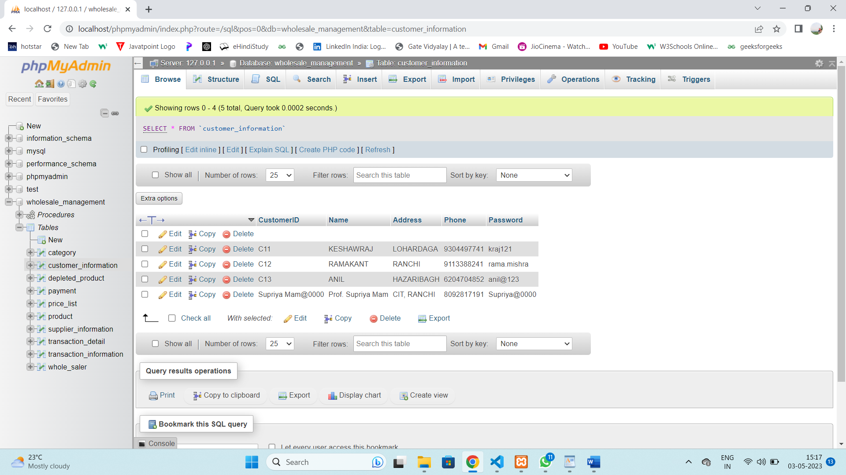

Fig 6.1

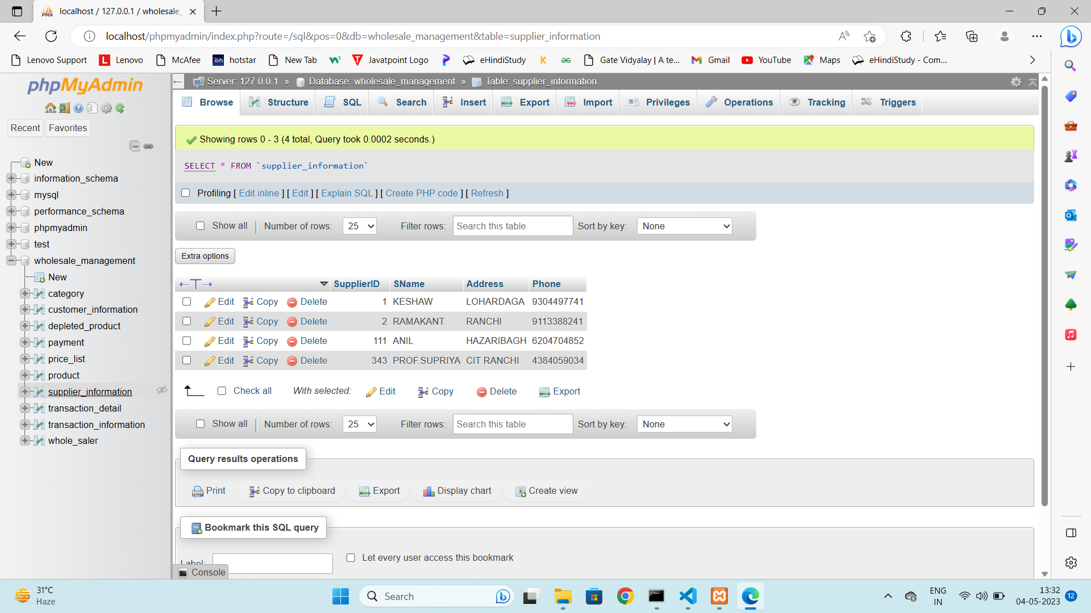

Fig 6.2

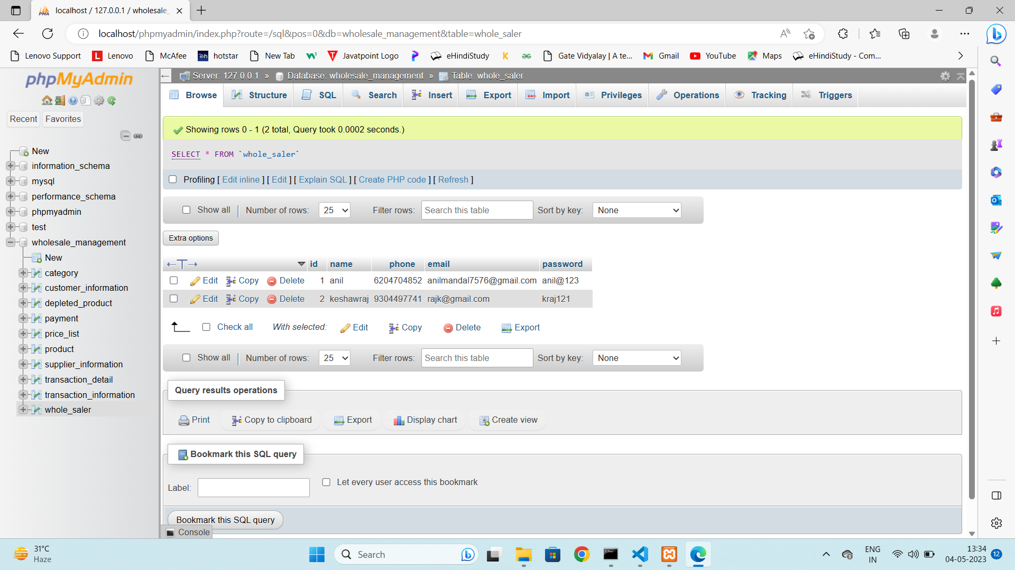

Fig 6.3

**7. Output**

Whole Saler Login

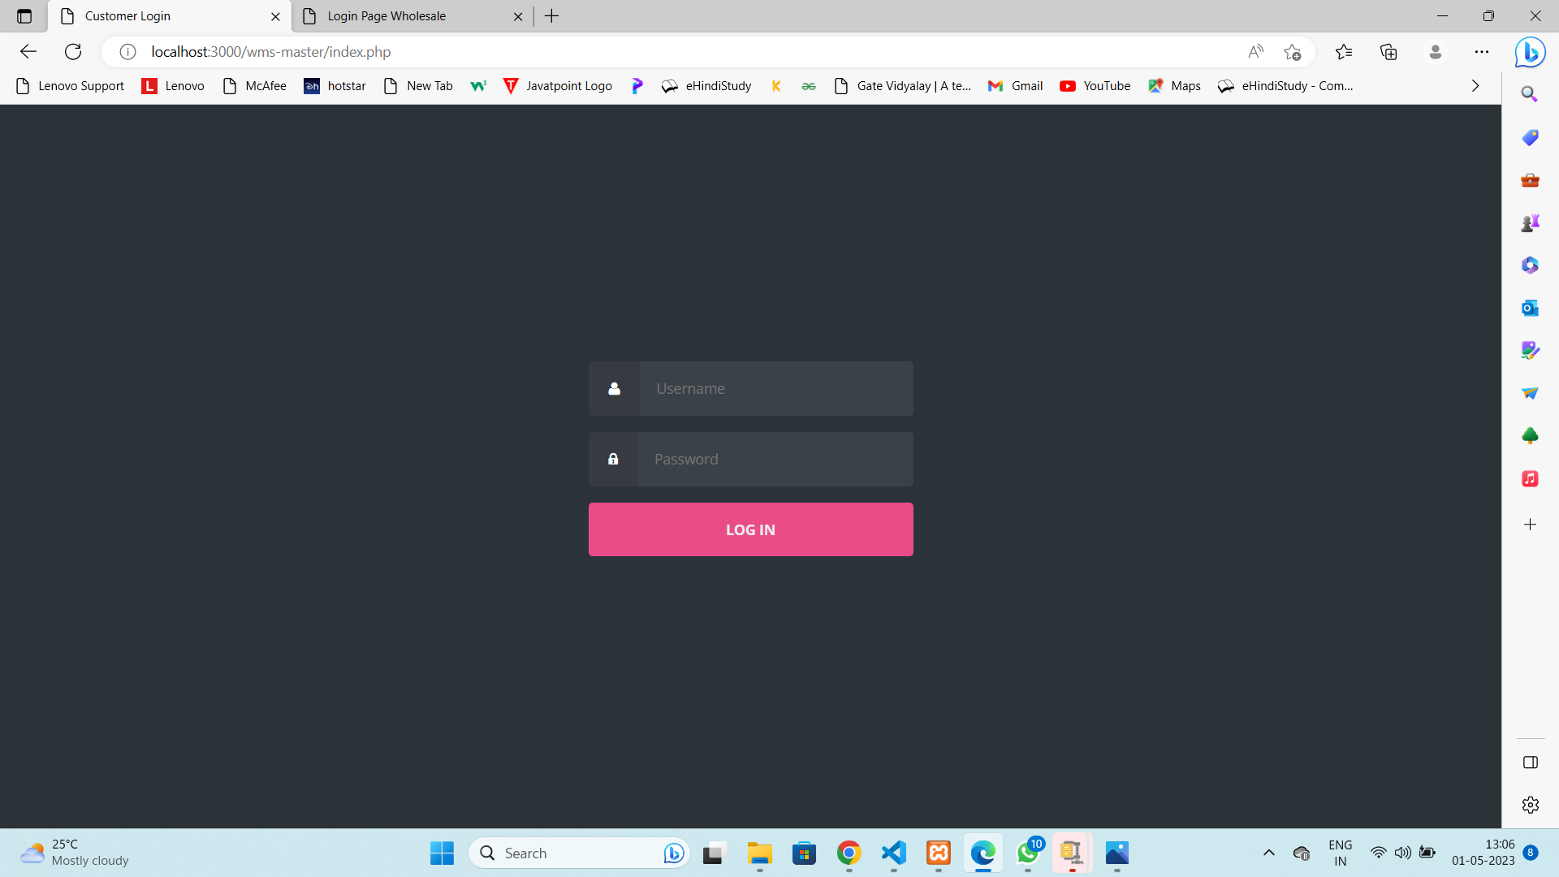

Fig 7.1

Whole Saler Homepage

Fig 7.2

Whole saler New Transaction

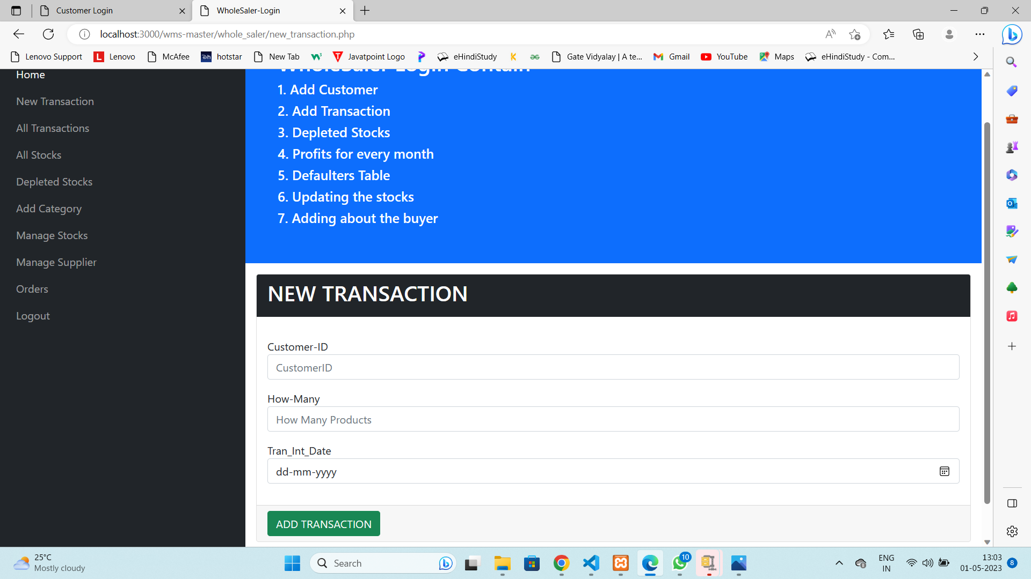

Fig 7.3

Whole Saler All Stock

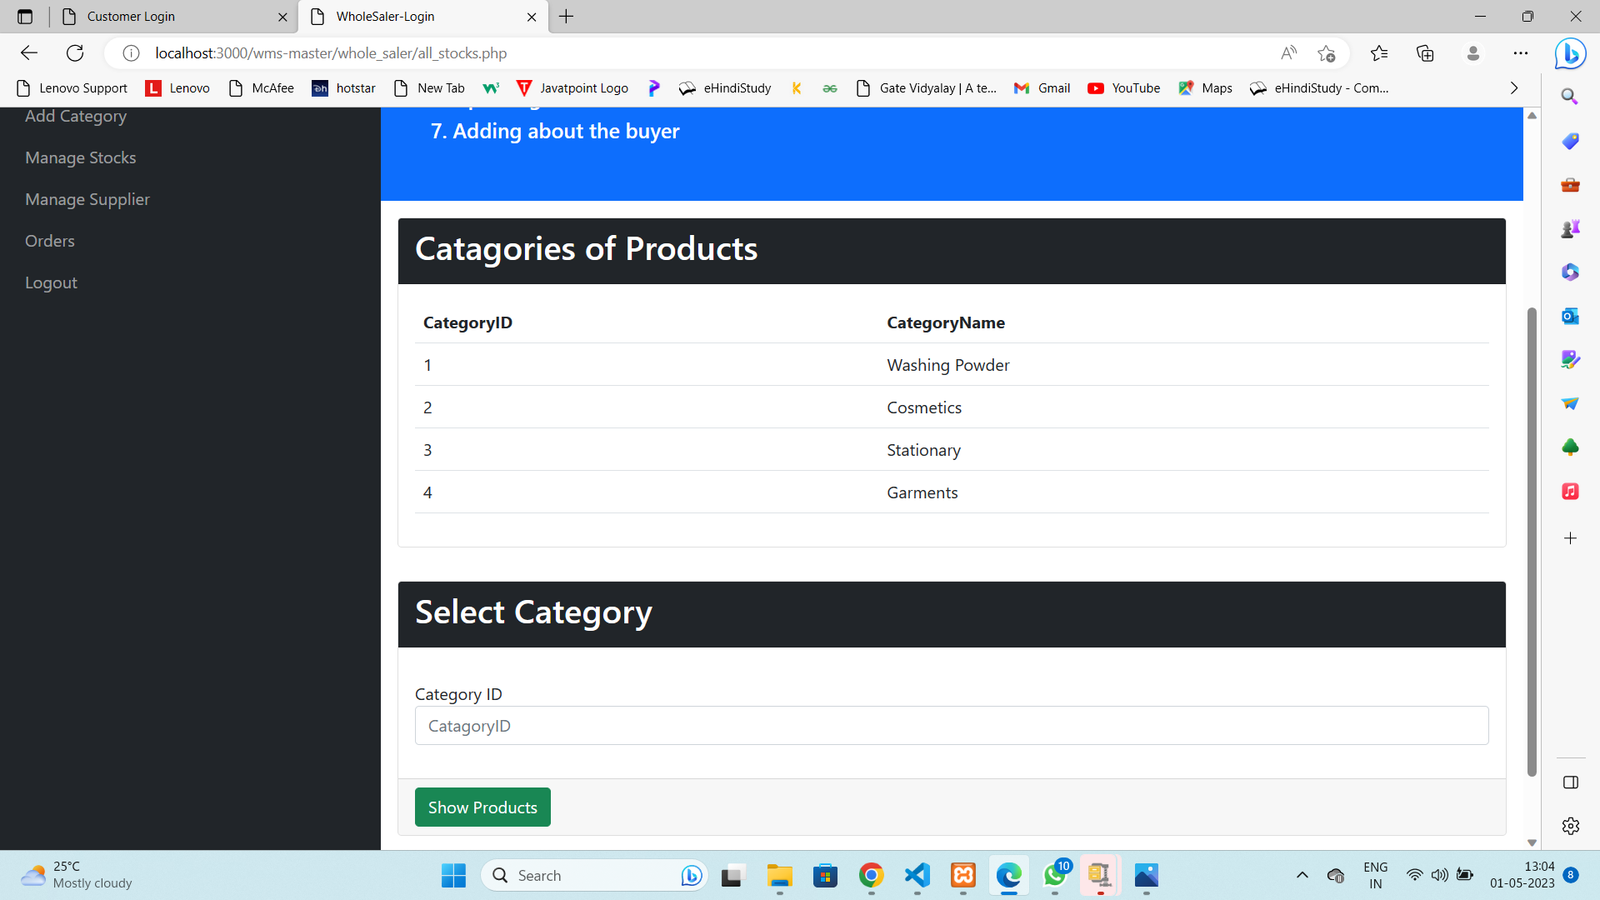

Fig 7.4

Whole saler Add Category

Fig 7.5

Whole Saler Manage Stock

Fig 7.6

Whole Saler Manage Supplier

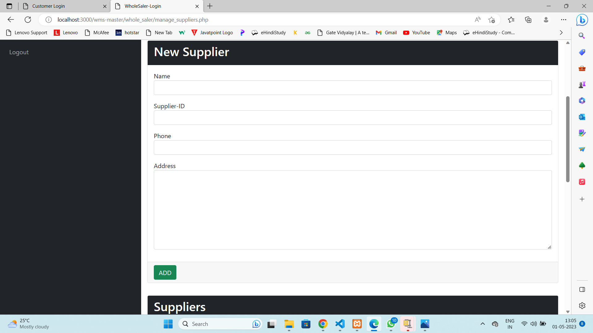

Fig 7.7

Wholes saler Update Supplier

Fig 7.7

Whole Saler Order Details

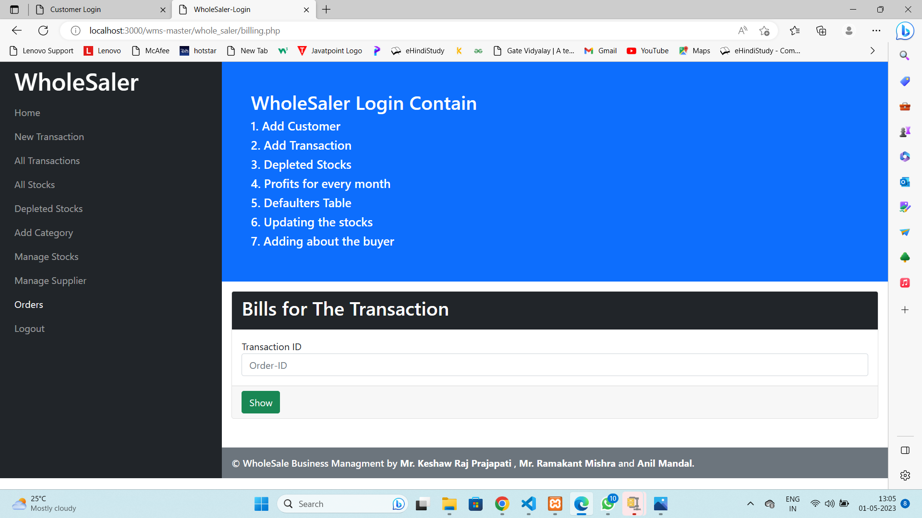

Fig 7.8

Whole saler Logout

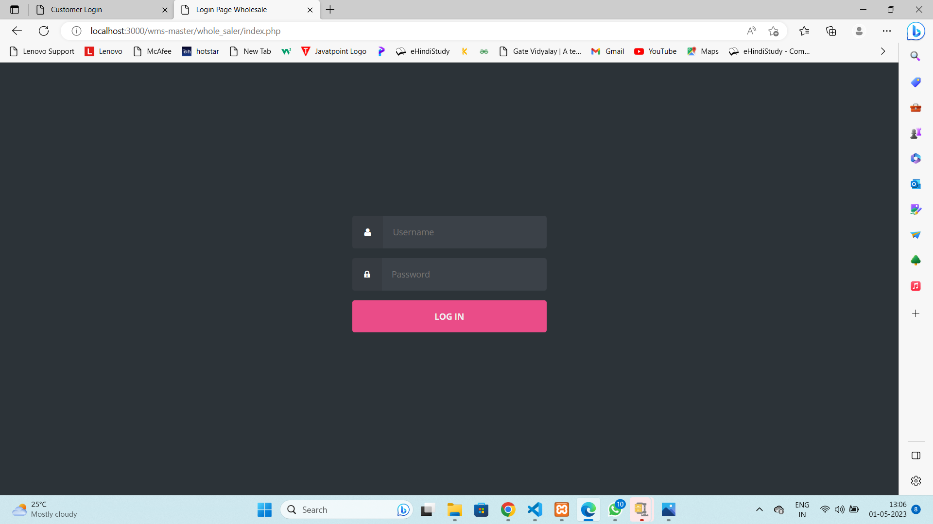

. Fig 7.9

Customer Home page

Fig 7.10

Customer Categories

Fig 7.11

Customer Date to Date Transaction

Fig 7.12

Customer Payment Details

Fig 7.13

**8.Conclusion**

wholesale management system is a software solution that helps businesses manage their inventory, sales, orders, and customer information. It streamlines processes, reduces costs, and improves efficiency. In conclusion, a wholesale management system is essential for businesses that deal with large volumes of products and customers. It provides a central hub for managing all aspects of the business, including inventory, sales, orders, and customer data. With the right wholesale management system, businesses can increase their productivity, reduce errors, and improve customer satisfaction**.** Wholesale system is the process of buying the stocks from the buyers and then selling it to the customers. It acts as a middle person between the buyers and the sellers. Management system ensures the proper dealing and security of the data of the shop.This new system that will be developed will contain database that enable data storage and retrieving of each transactions and data about inventory of each items in the store, manage the product releases and storage and summarize point of sales. This would generate a faster improvisation of work with less time and effort. As the concept of Sales and Inventory Management System is to reduce paper works and ineffective ways of managing inventory, this system is expected to assist in making the right decision in the process of managing inventory aligned with the sales level in the store.

This is a small prototype of a sales management application for a wholesale business. The limitation of the application is that it lacks enough features to be implemented in a real life situation. Such an application, if built with professional expertise, can be highly useful cost effective way for small businesses to manage themselves efficiently. A wholesale business works completely on the concept of offline transactions thus making it easy to manage such an application since it doesn’t have to manage online transactions, yet a the same time making the business records more secure.

## 9.Future Scope

The future scope of wholesale management systems is promising, as the industry is constantly evolving to meet the needs of businesses and customers. Some potential developments and trends that could shape the future of wholesale management systems include:

Artificial Intelligence (AI) and Machine Learning (ML): The integration of AI and ML technologies into wholesale management systems can enable businesses to automate repetitive tasks, analyze customer data, and make better decisions based on data insights.

Mobile optimization: The increasing use of mobile devices for business operations means that wholesale management systems will need to be optimized for mobile devices to allow users to access information on-the-go.

Integration with other systems: Wholesale management systems will need to integrate with other systems such as CRM, ERP, and accounting software to streamline business processes and reduce data entry errors.

Cloud-based solutions: Cloud-based wholesale management systems can provide businesses with greater flexibility, scalability, and accessibility, enabling them to manage their operations from anywhere.

Increased focus on sustainability: As more businesses focus on sustainability, wholesale management systems will need to incorporate features that allow businesses to track and manage their environmental impact, such as tracking carbon emissions and managing waste.

In summary, the future of wholesale management systems is bright, with advancements in AI, mobile optimization, integration, cloud-based solutions, and sustainability all playing a crucial role in shaping the industry.

**10. REFERENCES**

[1] K. Christidis and M. Devetsikiotis, “Blockchains and smart contracts for the internet of things,” Ieee Access vol. 4, pp. 2292– 2303, 2016.

[2] Y. He, H. Li, X. Cheng, Y. Liu, C. Yang, and L. Sun, “A blockchain based truthful incentive mechanism for distributed p2p applications,” IEEE Access, vol. 6, pp. 27 324–27 335, 2018.

[3] V. Hassija, V. Chamola, S. Garg, N. G. K. Dara, G. Kaddoum, and D. N. K. Jayakody, “A blockchainbased framework for lightweight data sharing and energy trading in v2g network,” IEEE Transactions on Vehicular Technology, 2020.

[4] A. C. Chapman and G. Verbic, “An iterative on-line ˇ auction mechanism for aggregated demand-side participation,” IEEE Transactions on Smart Grid, vol. 8, no. 1, pp. 158–168, 2017.

[5] F. You, J. Li, J. Lu, and F. Shu, “On the auction-based resource trading for a small-cell caching system,” IEEE Communications Letters, vol. 21, no. 7, pp. 1473–1476, 2017.

[6] Y. Yuan and F.-Y. Wang, “Blockchain and cryptocurrencies: Model, techniques, and applications,” IEEE Transactions on Systems, Man, and Cybernetics: Systems, vol. 48, no. 9, pp. 1421–1428, 2018.

[7] W. Chen, Z. Zheng, E. Ngai, P. Zheng, and Y. Zhou, “Exploiting blockchain data to detect smart ponzi schemes on ethereum,” IEEE Access, 2010

**Appendix (Coding)**

<?php

session_start();

if($_SESSION['Login']!="Active")

{

header("location:index.php");

}

?>

<!DOCTYPE html>

<html lang="en">

<head>

<title>WholeSaler-Login</title>

<?php include('links.php'); ?>

</head>

<body>

<div class="container-fluid">

<div class="row">

<div class="col-sm-12 col-md-4 col-lg-3 p-0 bg-dark">

<nav class="navbar bg-dark navbar-dark">

<div class="container-fluid">

<ul class="navbar-nav">

<li class="nav-item">

<p class="h1 text-white">WholeSaler</p>

</li>

<li class="nav-item">

<a

class="nav-link" href="whole_saler_index.php">Home</a>

</li>

<li class="nav-item">

<a

class="nav-link" href="new_transaction.php">New Transaction</a>

</li>

<li class="nav-item">

<a

class="nav-link" href="all_transactions.php">All Transactions</a>

</li>

<li class="nav-item">

<a class="nav-link" href="all_stocks.php">All Stocks</a>

</li>

<li class="nav-item">

<a

class="nav-link" href="depleted_stock.php">Depleted Stocks</a>

</li>

<li class="nav-item">

<a class="nav-link

active" href="add_category.php">Add Category</a>

</li>

<li class="nav-item">

<a

class="nav-link" href="manage_stocks.php">Manage Stocks</a>

</li>

<li class="nav-item">

<a

class="nav-link"

href="manage_suppliers.php">Manage Supplier</a>

</li>

<li class="nav-item">

<a

class="nav-link" href="billing.php">Orders</a>

</li>

<li class="nav-item">

<a

class="nav-link" href="logout.php">Logout</a>

</li>

</ul>

</div>

</nav>

</div>

<div class="col-sm-12 col-md-8 col-lg-9 p-0">

<?php include('wholesaler_login_contain.php');?>

<div class="container-fluid p-3">

<div class="card m-0">

<form action="add_category.php" method="POST">

<div class="card-header bg-dark text-white">

<p class="h2">New Catagory</p>

</div>

<div class="card-body">

<div class="mb-3 mt-3">

<label for="CategoryID">Category ID</label>

<input type="integer" class="form-control" name="CategoryID" id="CategoryID"

placeholder="CategoryID" required />

</div>

<div class="mb-3">

<label for="CategoryName">Category Name</label>

<input type="text" class="form-control" name="CategoryName" id="CategoryName"

placeholder="CategoryName" required />

</div>

<div class="mb-3"></div>

</div>

<div class="card-footer">

<input type="submit" name="AddC" class="btn btn-success" value="Add Category" />

</div>

</form>

</div>

</div>

<div class="container-fluid p-3">

<?php

}?>

<div class="card m-0">

<div class="card-header bg-dark text-white">

<p class="h2">Categories of products</p>

</div>

<div class="card-body">

<table class="table table-hover">

<tr>

<th>CategoryID</th>

<th>CategoryName</th>

</tr>

<?php

<tr>

<td><?php echo $row['CategoryID']; ?></td>

<td><?php echo $row['CategoryName']; ?></td>

</tr>

<?php } while($row = mysqli_fetch_assoc($result)) ?>

<tr>

</table>

</div>

</div>

</div>

<?php include('footer.php'); ?>

</div>

</div>

</div>

</body>

</html>

?php

session_start();

$_SEESION["pass"] = "True";

?>

<!DOCTYPE html>

<html>

<head>

<meta charset="UTF-8">

<title>Customer Login</title>

<link rel="stylesheet" href="css/style.css">

</head>

<body>

<body class="align">

<div class="site__container">

<div class="grid__container">

<form action="login_validation.php" method="post" class="form form--login">

<div class="form__field">

<label class="fontawesome-user" for="login__username"><span

class="hidden">Username</span></label>

<input id="login__username" name="userid" type="text" class="form__input" placeholder="Username"

required>

</div>

<div class="form__field">

<label class="fontawesome-lock" for="login__password"><span

class="hidden">Password</span></label>

<input id="login__password" name="pass" type="password" class="form__input"

placeholder="Password" required>

</div>

<div class="form__field">

<input type="submit" name="Login" value="Log In">

</div>

</form>

</div>

</div>

</body>

</body>

</html>

<?php

session_start();

if($_SESSION['Login']!="Active")

{

header("location:index.php");

}

?>

<!DOCTYPE html>

<html lang="en">

<head>

<title>WholeSaler-Login</title>

<?php include('links.php'); ?>

</head>

<body>

<div class="container-fluid">

<div class="row">

<div class="col-sm-12 col-md-4 col-lg-3 p-0 bg-dark">

<nav class="navbar bg-dark navbar-dark">

<div class="container-fluid">

<ul class="navbar-nav">

<li class="nav-item">

<p class="h1 text-white">WholeSaler</p>

</li>

<li class="nav-item">

<a class="nav-link" href="whole_saler_index.php">Home</a>

</li>

<li class="nav-item">

<a class="nav-link" href="new_transaction.php">New Transaction</a>

</li>

<li class="nav-item">

<a class="nav-link" href="all_transactions.php">All Transactions</a>

</li>

<li class="nav-item">

<a class="nav-link" href="all_stocks.php">All Stocks</a>

</li>

<li class="nav-item">

<a class="nav-link" href="depleted_stock.php">Depleted Stocks</a>

</li>

<li class="nav-item">

<a class="nav-link active" href="add_category.php">Add Category</a>

</li>

<li class="nav-item">

<a class="nav-link" href="manage_stocks.php">Manage Stocks</a>

</li>

<li class="nav-item">

<a class="nav-link" href="manage_suppliers.php">Manage Supplier</a>

</li>

<li class="nav-item">

<a class="nav-link" href="billing.php">Orders</a>

</li>

<li class="nav-item">

<a class="nav-link" href="logout.php">Logout</a>

</li>

</ul>

</div>

</nav>

</div>

<div class="col-sm-12 col-md-8 col-lg-9 p-0">

<?php include('wholesaler_login_contain.php');?>

<div class="container-fluid p-3">

<div class="card m-0">

<form action="add_category.php" method="POST">

<div class="card-header bg-dark text-white">

<p class="h2">New Catagory</p>

</div>

<div class="card-body">

<div class="mb-3 mt-3">

<label for="CategoryID">Category ID</label>

<input type="integer" class="form-control" name="CategoryID" id="CategoryID"

placeholder="CategoryID" required />

</div>

<div class="mb-3">

<label for="CategoryName">Category Name</label>

<input type="text" class="form-control" name="CategoryName" id="CategoryName"

placeholder="CategoryName" required />

</div>

<div class="mb-3"></div>

</div>

<div class="card-footer">

<input type="submit" name="AddC" class="btn btn-success" value="Add Category" />

</div>

</form>

</div>

</div>

<div class="container-fluid p-3">

<?php

if(isset($_POST['AddC'])) {

$CategoryID = $_POST['CategoryID'];

$CategoryName = $_POST['CategoryName'];

$conn = mysqli_connect("localhost","root","","WholeSale_Management");

$sql = "INSERT INTO category VALUES ('$CategoryID','$CategoryName')";

$result = mysqli_query($conn,$sql);

}?>

<div class="card m-0">

<div class="card-header bg-dark text-white">

<p class="h2">Categories of products</p>

</div>

<div class="card-body">

<table class="table table-hover">

<tr>

<th>CategoryID</th>

<th>CategoryName</th>

</tr>

<?php

$conn mysqli_connect("localhost","root","","WholeSale_Management");

$sql = "SELECT * FROM category";

$result = mysqli_query($conn,$sql);

$row = mysqli_fetch_assoc($result);

do { ?>

<tr>

<td><?php echo $row['CategoryID']; ?></td>

<td><?php echo $row['CategoryName']; ?></td>

</tr>

<?php } while($row = mysqli_fetch_assoc($result)) ?>

<tr>

</table>

</div>

</div>

</div>

<?php include('footer.php'); ?>

</div>

</div>

</div>

</body>

</html>

"configurations": [

{

"name": "Win32",

"includePath": [

"${workspaceFolder}/**"

],

"defines": [

"_DEBUG",

"UNICODE",

"_UNICODE"

],

"cStandard": "c17",

"cppStandard": "c++17",

"intelliSenseMode": "windows-msvc-x64"

}

],

"version": 4

}

@import url(http://fonts.googleapis.com/css?family=Source+Sans+Pro:400,700);

/** global **/

body {

margin:0px auto;

padding:0;

background: #222;

font-family: "Source Sans Pro","sans-serif";

font-size: 1.0em;

color:#666;

}

* {

margin:0;

padding:0;

}

/** element defaults **/

table {

width:100%;

text-align:left;

}

th, td {

padding:5px 10px;

}

th {

color:#fff;

border-top:1px solid #222;

background-color:#2F2F2F;

}

td {

border-bottom:1px solid #f4f4f4;

}

code, blockquote {

display:block;

border-left:5px solid #ddd;

padding:10px;

margin-bottom:20px;

}

blockquote p {

font-style:italic;

font-family:Georgia, "Times New Roman", Times, serif;

margin:0;

height: 1%;

}

p {

line-height:2.0em;

margin-bottom:20px;

}

a {

color:#6FAB4F;

}

a:hover {

color:#000;

}

a:focus {

outline:none;

}

a.button {

background-color: #80B763;

border-radius: 5px;

color: #FFFFFF;

display: inline-block;

font-weight: bold;

padding: 8px 22px;

font-size: 0.8em;

letter-spacing: 0.25px;

text-decoration: none;

text-transform: uppercase;

}

a.button-reversed {

background-color: #333;

}

a.button:hover {

background-color: #669D48;

}

a.button-reversed:hover {

background-color: #222;

}

fieldset {

display:block;

border:none;

border-top:1px solid #e0e0e0;

}

fieldset legend {

font-weight:bold;

padding-right:10px;

color:#999;

}

fieldset form {

padding-top:15px;

}

fieldset p label {

float:left;

width:150px;

font-family: "Source Sans Pro","sans-serif";

}

fieldset form input, fieldset form select, fieldset form textarea {

padding:5px;

color:#333333;

font-size:13px;

font-family: "Source Sans Pro","sans-serif";

border:1px solid #ddd;

}

fieldset form input.formbutton {

border:none;

background-color: tomato;

border-radius: 5px;

color: #FFFFFF;

display: inline-block;

font-weight: bold;

padding: 8px 22px;

font-size: 0.8em;

letter-spacing: 0.25px;

text-decoration: none;

text-transform: uppercase;

}

h1 {

font-size:2.0em;

}

h2 {

color:#2f2f2f;

font-size:1.8em;

font-weight:bold;

padding:0 0 5px;

margin:0;

}

h3 {

color:#80B763;

font-size:1.6em;

padding-bottom:10px;

}

h4 {

padding-bottom:10px;

font-size:1.4em;

color:#000;

}

h5 {

padding-bottom:10px;

font-size:1.2em;

color:#666666;

}

ul, ol {

margin:0 0 35px 35px;

}

li {

padding-bottom:5px;

}

/** wrapper **/

div#wrapper {

margin:0px auto;

padding:0;

}

.width {

width:auto;

margin: 0 auto;

}

/** header **/

header {

padding:30px 17px 30px;

margin:0 auto;

}

header h1 {

text-align: right;

}

header h1 a,

header h1 a:hover,

header h1 a:visited {

color: #fff;

font-size: 1.5em;

text-decoration: none;

letter-spacing:-2px;

}

header h2 {

color:#C4DDB6;

text-align: right;

font-size: 0.8em;

font-weight: normal;

padding-bottom:0;

letter-spacing:0;

}

/** body **/

section#body {

padding: 0;

background: tomato;

}

/** content+sidebar styles **/

section#content {

margin-left: 250px;

padding: 20px;

background-color: #fff;

}

.column-left {

float:left;

}

.column-right {

float:right;

}

aside#sidebar {

width:250px;

position: fixed;

}

nav#mainnav ul {

padding: 0;

margin: 0;

list-style: none;

}

nav#mainnav li {

padding:0;

border-bottom: 1px solid #99C581;

border-top: 1px solid #6FAB4F;

}

nav#mainnav li.selected-item {

border-bottom:none;

}

nav#mainnav li.selected-item a,++++++++++++++++++++++++++++++++++++++++++++++++++++++++++++++++++++

nav#mainnav li.selected-item a:hover {

color:tomato;

font-weight:bold;

background: #fff;

}

nav#mainnav li a:hover {

background:tomato;

color: #fff;

text-decoration:none;

}

nav#mainnav li a {

color: #f0f0f0;

display: block;

padding: 15px 17px;

text-align: right;

font-weight: bold;

text-decoration: none;

}

article {

padding: 10px 10px 30px;

font-size: 1.2em;

border-bottom: 1px solid #eee;

}

article h2 {

padding-bottom: 0;

line-height: 1.1em;

letter-spacing: -2px;

font-size: 2.5em;

}

article .article-info {

color: #C0c0c0;

font-size: 0.92em;

padding: 0px 0px 10px;

}

article .article-info a {

color: #ccc;

}

/** footer **/

footer {

padding:20px 0px;

}

footer p {

color:#666;

margin:0;

font-size:0.8em;

text-align: center;

}

footer p a {

color:#666;

font-weight:bold;

text-decoration:none;

border-bottom:1px solid #999;

}

footer p a:hover { color:#333; border-bottom-color: #333; }

/** clear fix **/

.clear:after {

display: block;

clear: both;

visibility: hidden;

line-height: 0;

height: 0;

}

.clear {

clear: both;

display: inline-block;

}

.clear {

display: block;

}